Create Database migrate:
----------------------------------------------------------------------------------------------------------------------
Step-by-Step Azure Server Migration: A Guide for Architects (k21academy.com)
Step-by-Step Azure Server Migration: A Guide for Architects (k21academy.com)
1.Go to Azure portal
2.azure Migrate
3. select Server and database option and click on Project. Create a Project.
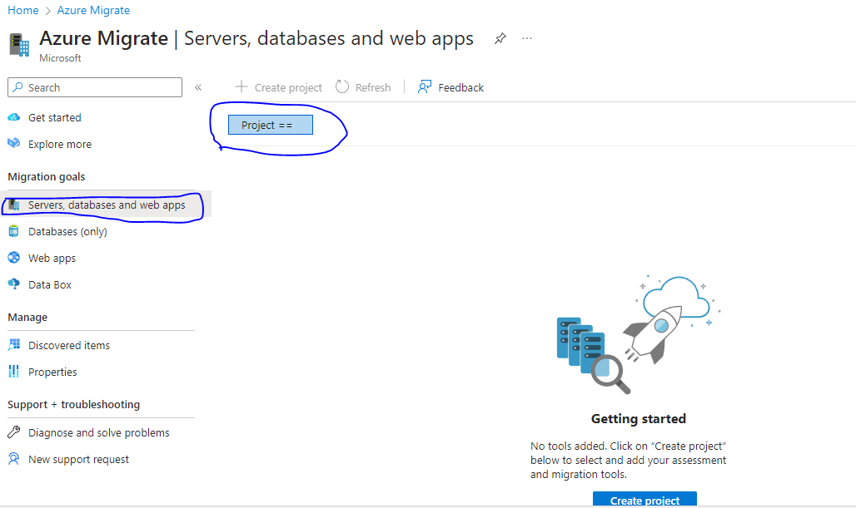
4.Create a Project fill all details

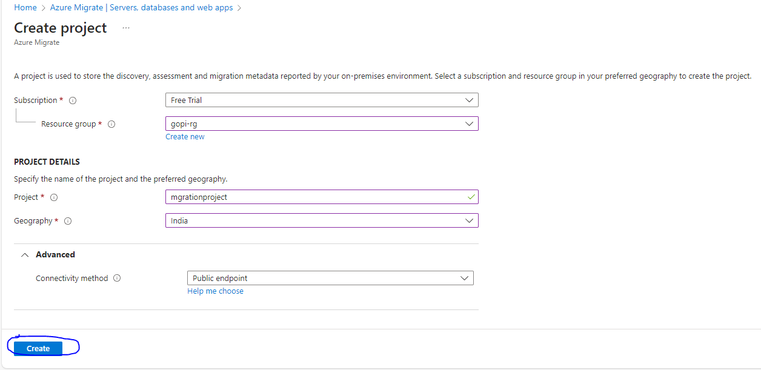
5.

